**JAVA PROJECT**

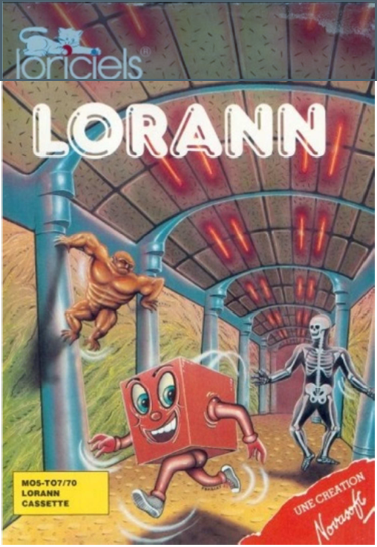

**Project presentation:**

LORANN is a pac-man like game released in 1985. In this game, we have to run away from ghosts trying to killing us and find a key in order to escape the level by a door. We had to re-code this abandonware in JAVA language. We code five levels more and more difficult with, for each one, a different map. Once you reach the door you passed to the next level. Finally you finished the game by ending the fifth level. When you play the game, make sure your sound system is on.

**Deliverables**

You can find the Javadoc in the component Contract.

All the diagrams are in the Java Project.vpp except the sequence diagram which is in Java Project2.vpp.

When we try to build a SureFire report, we had a lot of problems with Maeven’s dependencies. So, we decided to had screenshot of every Junit Tests in order to show the well-working of them.

**Personal review:**

**Rémi PAPIN:** I miss half of the project due to a mononucleosis. Nevertheless, I follow the project’s advancements and help to write some parts of the game. When I come back, I write all the Junit tests and help Corentin for the diagram sequence. I must learn how does every method work for writing the tests. I met many problems but with the help of my teammate we release all the deliverables asked.

This project was long nevertheless, it was interesting and gave us a huge sense of accomplishment.

**Corentin BRION:** During this project I have work on the UML and the program. I have some problems with Maven when we start but with the time I have learned to know what is Maven. I have learned a lot of method during this project.

To finish I think this project was cool but too long.

**Corentin BOURGEY:**